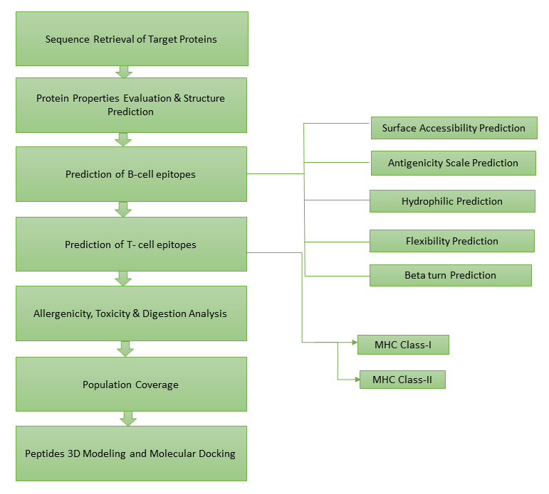
Figure S1: Schematic representation of methodology used in present study.

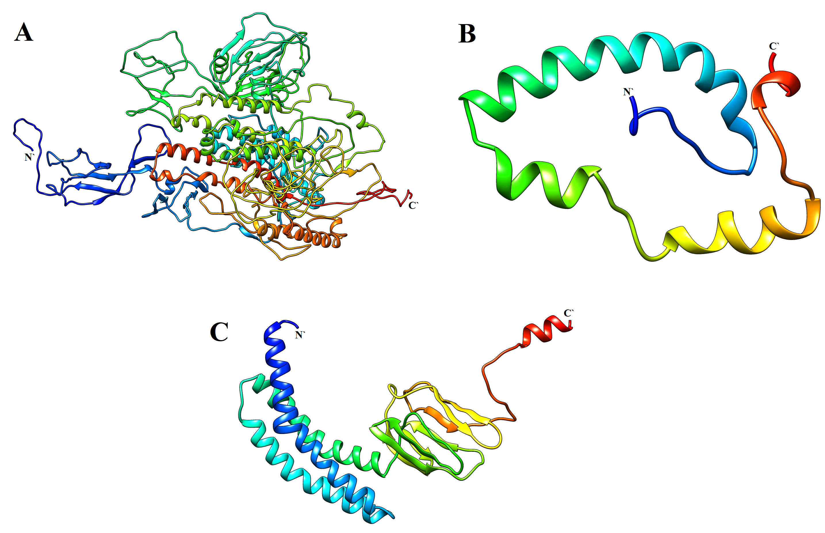
Figure S2. 3D structural representation of SARS-COV-2 structural proteins: (A) S protein, (B) E protein and (C) M protein.

Figure S3: (a) the S protein contains α-helix (49.01%, 624), β-strand (26.23%, 334) and random coil (24.74%, 315); (b) the z-score (-3.93) of the S protein; (c) the Ramachandran plot of refined structure shows 85.9%, 10.9% and 3.5% residues in favored, allowed and disallowed region, respectively.

Figure S4: (a) the E protein contains α-helix (77.33%, 58) and random coil (22.66%, 17); (b) the z-score (0.41) of the E protein; (c) the Ramachandran plot of refined structure shows 97.3%, 2.7% and 0.0% residues in favored, allowed and disallowed region, respectively.

Figure S5: (a) the M protein contains α-helix (40.54%, 90), β-strand (24.32%, 54) and random coil (35.13%, 78); (b) the z-score (-3.88) of the M protein; (c) the Ramachandran plot of refined structure shows 96.8%, 2.7% and 0.5% residues in favored, allowed and disallowed region, respectively.

Figure S6: (A) Prediction of antigenic determinants of S proteinusing Kolaskar and Tongaonkar antigenicity scale; (B) Beta Turns analyses in S protein using Chou and Fasman Beta Turn prediction; (C) Hydrophilicity Prediction of S protein using Parker Hydrophilicity; (D) Surface Accessibility Analyses of S protein using Emini Surface Accessibility Scale; (E) Flexibility Analyses of S protein using Karplus and Schulz Flexibility Scale.

Figure S7: (A) Prediction of antigenic determinants of E protein using Kolaskar and Tongaonkar antigenicity scale; (B) Beta Turns Analyses in E protein using Chou and Fasman Beta Turn Prediction; (C) Hydrophilicity Prediction of E protein using Parker Hydrophilicity; (D) surface accessibility analyses of E protein using Emini Surface Accessibility Scale; (E) Flexibility Analyses of E protein using Karplus and Schulz Flexibility Scale.

Figure S8: (A) Prediction of antigenic determinants of M protein using Kolaskar and Tongaonkar Antigenicity Scale; (B) Beta turns analyses in M protein using Chou and Fasman Beta Turn Prediction; (C) Hydrophilicity Prediction of M protein using Parker Hydrophilicity; (D) Surface Accessibility Analyses of M protein using Emini Surface Accessibility Scale; (E) Flexibility Analyses of M protein using Karplus and Schulz Flexibility Scale.

Figure S9: 3D structures of MHC Class I peptides predicted by PEPFOLD

